哈尔滨工业大学计算学部
实验报告

课程名称：数据结构与算法
课程类型：专业核心基础课（必修）
实验项目：内存排序算法及其应用
实验题目：内存排序算法实验比较
实验日期：2023/11/8

班级：2203101
学号：2022113573
姓名：张宇杰

设计成绩 | 报告成绩 | 指导老师
 |  | 张岩

一、实验目的
排序是计算机科学中的常见任务，它将一组无序的数据元素按照某种规则重新排列，以使得数据呈现有序的状态，便于后续的查找、统计和分析等操。当数据量较小时，将数据全部读入内存并进行排序的算法称为内存排序算法，常见的内存排序算法有：插入排序、冒泡排序、归并排序、快速排序、堆排序、基数排序等。本实验要求设计并实现上述内存排序算法并比较其运行速度。
二、实验要求及实验环境
1. 从文本文件中将两行数据读入内存，其中第一行有一个整数n(n≤100000)，表示待排序序列的长度，第二行有n个整数，用空格隔开，表示待排序序列
2. 实现归并排序、快速排序算法，输出排序好的序列，并记录算法运行时间
3. 实现选择排序算法或插入排序算法，并将其运行时间与归并排序、快速排序算法比较，随机生成多个适当规模的数据进行实验并绘制折线图，反映不同算法运行时间随着输入规模的变化趋势，并与理论分析结果进行比较
三、设计思想（本程序中的用到的所有数据类型的定义，主程序的流程图及各程序模块之间的调用关系、核心算法的主要步骤）
1．逻辑设计
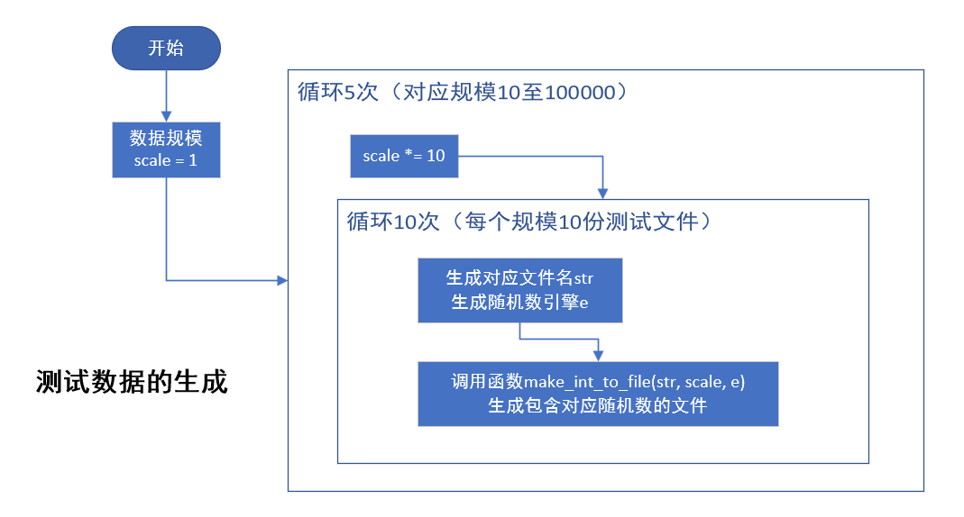
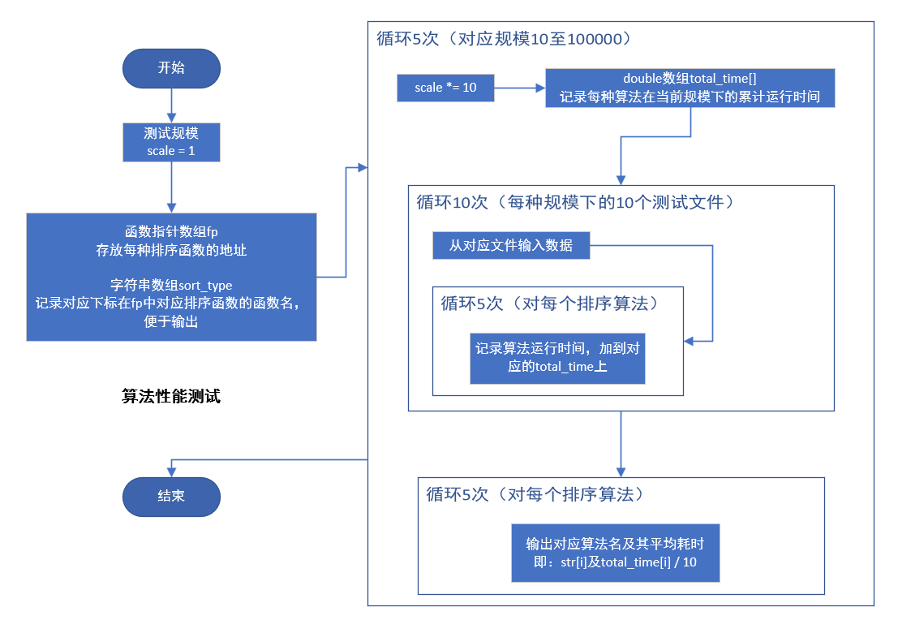
2．物理设计（即存储结构设计）
仅使用数组作为数据的存储结构
四、测试结果（包括测试数据、结果数据及结果的简单分析和结论，可以用截图得形式贴入此报告）
1、测试数据的生成
make_input.cpp
- #include "./src/sort.hpp"

- using namespace std;

- int main() {
- int scale = 1;

- for (int i = 1; i <= 5; ++i) {
- scale *= 10;

- string title = "./inputs/input_" + to_string(scale) + '_';
- string suffix = ".txt";
- default_random_engine e;
- e.seed(time(0));
- for (int j = 0; j < 10; ++j)
- My::make_int_to_file(title + to_string(j) + suffix, scale, e);
- }

- return 0;
- }
My::make_int_to_file
- namespace My {

- /**
- * @brief generate random integer
- * @param dest output stream destination
- * @param length generated number count
- * @note separated with space (aka char ' ')
- */
- void make_int(::std::ostream& dest, int length, ::std::default_random_engine& e) {
- ::std::uniform_int_distribution<int> u(INT32_MIN, INT32_MAX);
- for (int i = 0; i < length; ++i) {
- dest << u(e) << ' ';
- }
- }

- /**
- * @brief generate random integer to file
- * @param path file path
- * @param length generated number count
- * @note output: first line the <length>, second line numbers
- */
- void make_int_to_file(const ::std::string& path, int length, ::std::default_random_engine& e) {
- ::std::ofstream file(path);
- file << length << '\n';
- make_int(file, length, e);
- file.close();
- }

- ............
- }
运行结果：
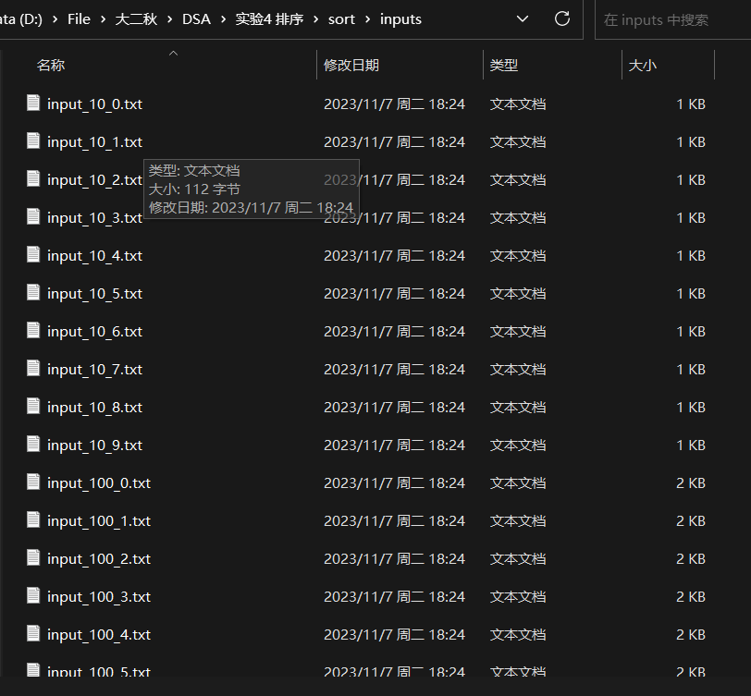
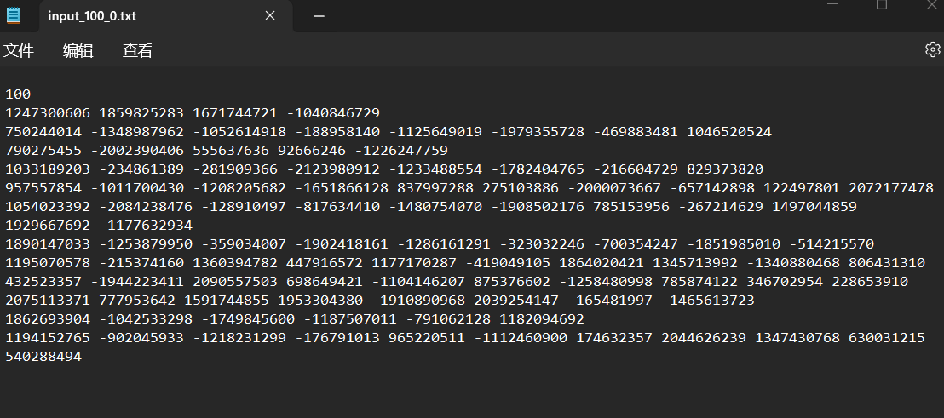
正确生成了对应测试文件

算法运行测试
运行程序
- int main(){
- int scale = 1;

- void (*fp[5]) (int*, int) = {
- My::selection_sort<int>,
- My::insertion_sort<int>,
- My::quick_sort<int>,
- My::merge_sort<int>,
- My::heap_sort<int>
- };

- string sort_type[5] = {
- "selection_sort",
- "insertion_sort",
- "quick_sort",
- "merge_sort",
- "heap_sort"
- };

- double total_time[5] = {0};
- string prefix = "./inputs/input_";
- string suffix = ".txt";

- for (int i = 1; i <= 5; ++i) { // for every scale
- scale *= 10;

- // clear
- for (int m = 0; m < 5; ++m)
- total_time[m] = 0;

- for (int j = 0; j < 10; ++j) { // for every file in same scale
- string filename = prefix + to_string(scale) + '_' + to_string(j) + suffix;

- // read file
- ifstream input(filename);
- int n = 0;
- input >> n;
- for (int m = 0; m < n; ++m)
- input >> arr[m];

- for (int k = 0; k < 5; ++k) { // for every sort way
- memcpy(temp, arr, sizeof(int) * scale);
- auto start = chrono::system_clock::now();

- fp[k](temp, scale);

- auto end = chrono::system_clock::now();
- auto duration = chrono::duration_cast<chrono::microseconds>(end - start);
- total_time[k] += double(duration.count()) * chrono::microseconds::period::num / chrono::microseconds::period::den;
- }
- }

- cout << "In scale " << scale << '\n';
- for (int m = 0; m < 5; ++m) {
- cout << sort_type[m] << ": " << total_time[m] / 10 << " s\n";
- }
- cout << endl;
- }

- return 0;
- }
输出结果
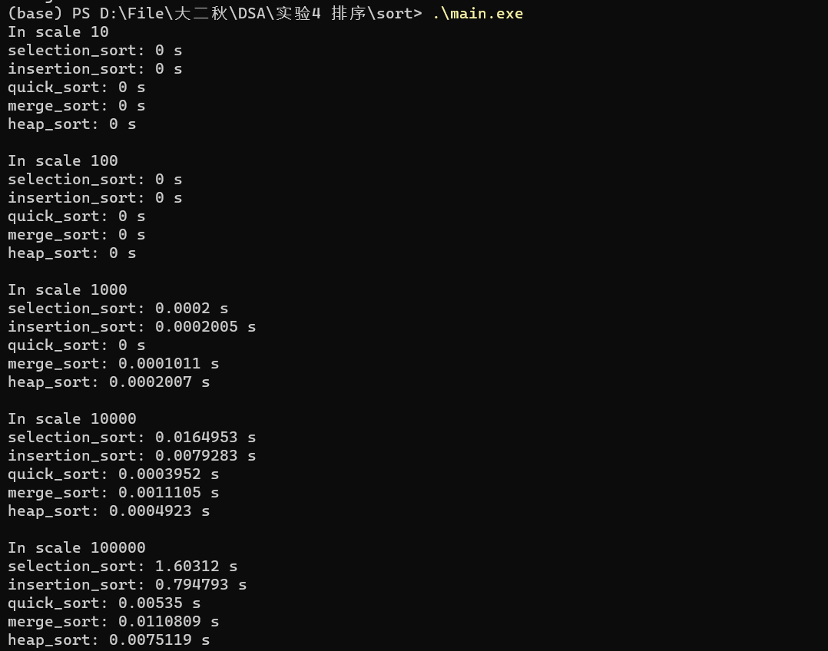
绘制图表
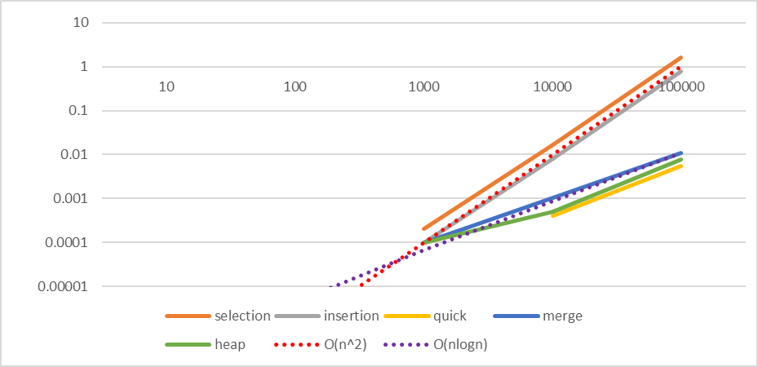
实际数据与理论符合性较好
五、经验体会与不足
加深了对各排序算法的理解
六、附录：源代码（带注释）
main.cpp
- #define DEBUG 0

- #include "./src/sort.hpp"
- #include <chrono>

- using namespace std;

- int arr[100007];
- int temp[100007];

- #if DEBUG // DEBUG == 1

- int main() {
- ifstream input_1("./inputs/input_100_0.txt");
- ifstream input_2("./inputs/input_100_1.txt");
- int n = 0;

- input_1 >> n;
- for (int i = 0; i < n; ++i)
- input_1 >> arr[i];

- auto start = chrono::system_clock::now();
- My::quick_sort(arr, 0, 99);
- auto end = chrono::system_clock::now();
- auto duration = chrono::duration_cast<chrono::microseconds>(end - start);
- double t1 = double(duration.count()) * chrono::microseconds::period::num / chrono::microseconds::period::den;

- cout << "sorted by quick_sort\n";
- for (int i = 0; i < n; ++i)
- cout << arr[i] << '\n';
- cout << "using time: " << t1 << " seconds" << endl;

- input_2 >> n;
- for (int i = 0; i < n; ++i)
- input_2 >> arr[i];

- start = chrono::system_clock::now();
- My::merge_sort(arr, 0, 99);
- end = chrono::system_clock::now();
- duration = chrono::duration_cast<chrono::microseconds>(end - start);
- double t2 = double(duration.count()) * chrono::microseconds::period::num / chrono::microseconds::period::den;

- cout << "sorted by merge_sort\n";
- for (int i = 0; i < n; ++i)
- cout << arr[i] << '\n';
- cout << "using time: " << t2 << " seconds" << endl;
- }

- #else // DEBUG == 0

- int main(){
- int scale = 1;

- void (*fp[5]) (int*, int) = {
- My::selection_sort<int>,
- My::insertion_sort<int>,
- My::quick_sort<int>,
- My::merge_sort<int>,
- My::heap_sort<int>
- };

- string sort_type[5] = {
- "selection_sort",
- "insertion_sort",
- "quick_sort",
- "merge_sort",
- "heap_sort"
- };

- double total_time[5] = {0};
- string prefix = "./inputs/input_";
- string suffix = ".txt";

- for (int i = 1; i <= 5; ++i) { // for every scale
- scale *= 10;

- // clear
- for (int m = 0; m < 5; ++m)
- total_time[m] = 0;

- for (int j = 0; j < 10; ++j) { // for every file in same scale
- string filename = prefix + to_string(scale) + '_' + to_string(j) + suffix;

- // read file
- ifstream input(filename);
- int n = 0;
- input >> n;
- for (int m = 0; m < n; ++m)
- input >> arr[m];

- for (int k = 0; k < 5; ++k) { // for every sort way
- memcpy(temp, arr, sizeof(int) * scale);
- auto start = chrono::system_clock::now();

- fp[k](temp, scale);

- auto end = chrono::system_clock::now();
- auto duration = chrono::duration_cast<chrono::microseconds>(end - start);
- total_time[k] += double(duration.count()) * chrono::microseconds::period::num / chrono::microseconds::period::den;
- }
- }

- cout << "In scale " << scale << '\n';
- for (int m = 0; m < 5; ++m) {
- cout << sort_type[m] << ": " << total_time[m] / 10 << " s\n";
- }
- cout << endl;
- }

- return 0;
- }

- #endif // DEBUG
make_input.cpp
- #include "./src/sort.hpp"

- using namespace std;

- int main() {
- int scale = 1;

- for (int i = 1; i <= 5; ++i) {
- scale *= 10;

- string title = "./inputs/input_" + to_string(scale) + '_';
- string suffix = ".txt";
- default_random_engine e;
- e.seed(time(0));
- for (int j = 0; j < 10; ++j)
- My::make_int_to_file(title + to_string(j) + suffix, scale, e);
- }

- return 0;
- }
sort.hpp
- #ifndef _SORTS_HPP_
- #define _SORTS_HPP_

- #include <iostream>
- #include <functional>
- #include <random>
- #include <limits>
- #include <ctime>
- #include <string>
- #include <fstream>

- namespace My {

- /**
- * @brief generate random integer
- * @param dest output stream destination
- * @param length generated number count
- * @note separated with space (aka char ' ')
- */
- void make_int(::std::ostream& dest, int length, ::std::default_random_engine& e) {
- ::std::uniform_int_distribution<int> u(INT32_MIN, INT32_MAX);
- for (int i = 0; i < length; ++i) {
- dest << u(e) << ' ';
- }
- }

- /**
- * @brief generate random integer to file
- * @param path file path
- * @param length generated number count
- * @note output: first line the <length>, second line numbers
- */
- void make_int_to_file(const ::std::string& path, int length, ::std::default_random_engine& e) {
- ::std::ofstream file(path);
- file << length << '\n';
- make_int(file, length, e);
- file.close();
- }

- template <typename Elem, class CmpFunc>
- void selection_sort(Elem* arr, int len, CmpFunc cmp) {
- for (int i = 0; i < len; i++) {
- int l_index = i;
- for (int j = i + 1; j < len; j++)
- if (cmp(arr[j], arr[l_index]))
- l_index = j;
- ::std::swap(arr[i], arr[l_index]);
- }
- }

- template <typename Elem>
- void selection_sort(Elem* arr, int len) {
- selection_sort(arr, len, ::std::less<Elem>());
- }

- template <typename Elem, class CmpFunc>
- void insertion_sort(Elem* arr, int len, CmpFunc cmp) {
- for (int i = 1; i < len; i++) {
- Elem temp = arr[i];
- int j = i - 1;
- while (cmp(temp, arr[j]) && j >= 0) {
- arr[j + 1] = arr[j];
- --j;
- }
- arr[j + 1] = temp;
- }
- }

- template <typename Elem>
- void insertion_sort(Elem* arr, int len) {
- insertion_sort(arr, len, ::std::less<Elem>());
- }

- template <typename Elem, class CmpFunc>
- void merge_sort(Elem* arr, int l, int r, CmpFunc cmp) {
- if (l >= r)
- return;
- int mid = l + (r - l) / 2;

- merge_sort(arr, l, mid, cmp);
- merge_sort(arr, mid + 1, r, cmp);

- Elem* temp = new Elem[r - l + 1];
- int i = l, j = mid + 1, total = 0;
- while (i <= mid && j <= r) {
- if (cmp(arr[i], arr[j]))
- temp[total++] = arr[i++];
- else
- temp[total++] = arr[j++];
- }

- if (i <= mid)
- memcpy(temp + total, arr + i, (mid - i + 1) * sizeof(Elem));
- if (j <= r)
- memcpy(temp + total, arr + j, (r - j + 1) * sizeof(Elem));
- memcpy(arr + l, temp, (r - l + 1) * sizeof(Elem));

- delete[] temp;
- }

- template <typename Elem>
- void merge_sort(Elem* arr, int l, int r) {
- merge_sort(arr, l, r, ::std::less<Elem>());
- }

- template <typename Elem>
- void merge_sort(Elem* arr, int len) {
- merge_sort(arr, 0, len - 1);
- }

- template <typename Elem, class CmpFunc>
- void quick_sort(Elem* arr, int l, int r, CmpFunc cmp) {
- Elem pivot = arr[l + (r - l) / 2];
- int i = l, j = r;

- do {
- while (cmp(arr[i], pivot))
- ++i;
- while (cmp(pivot, arr[j]))
- --j;
- if (i <= j)
- ::std::swap(arr[i++], arr[j--]);
- } while (i <= j);

- if (l < j)
- quick_sort(arr, l, j, cmp);
- if (i < r)
- quick_sort(arr, i, r, cmp);
- }

- template <typename Elem>
- void quick_sort(Elem* arr, int l, int r) {
- quick_sort(arr, l, r, ::std::less<Elem>());
- }

- template <typename Elem>
- void quick_sort(Elem* arr, int len) {
- quick_sort(arr, 0, len - 1);
- }

- template <typename Elem, class CmpFunc>
- void heapify (Elem* arr, int len, int father, CmpFunc cmp) {
- int child = father * 2 + 1;
- // sink down process
- while (child < len) {
- // get the "maximum" child (depend on the cmp func)
- if (child + 1 < len && cmp(arr[child], arr[child + 1]))
- child++;

- // if father is "bigger" than child (depend on the cmp func)
- if (cmp(arr[child], arr[father]))
- // sink down over
- return;
- else {
- // swap father with the "bigger" child (depend on the cmp func)
- ::std::swap(arr[child], arr[father]);
- // child become father
- father = child;
- child = father * 2 + 1;
- }
- }
- }

- template <typename Elem, class CmpFunc>
- void heap_sort(Elem* arr, int len, CmpFunc cmp) {
- for (int i = (len - 1) / 2; i >= 0; i--)
- heapify(arr, len, i, cmp);

- for (int i = len - 1; i >= 0; i--) {
- ::std::swap(arr[0], arr[i]);
- heapify(arr, i, 0, cmp);
- }
- }

- template <typename Elem>
- void heap_sort(Elem* arr, int len) {
- heap_sort(arr, len, ::std::less<Elem>());
- }

- } // namespace My

- #endif // _SORTS_HPP_

